**Displaying User Feedback Output**

**Index page**

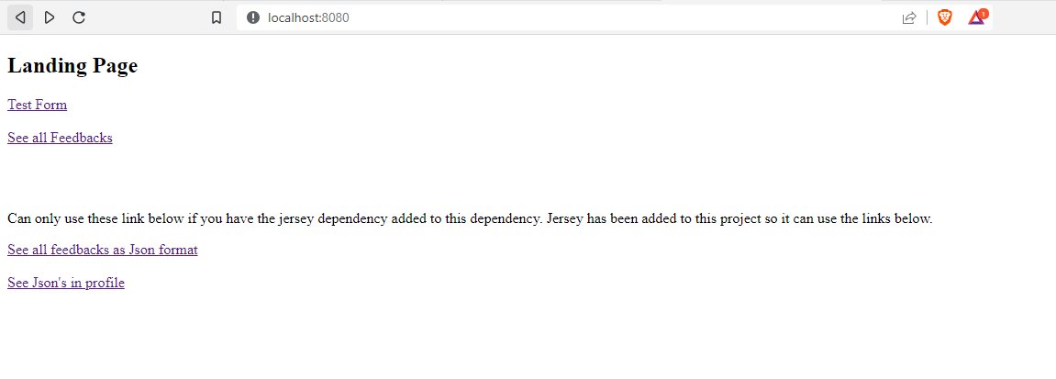

**User Rating and feedback page**

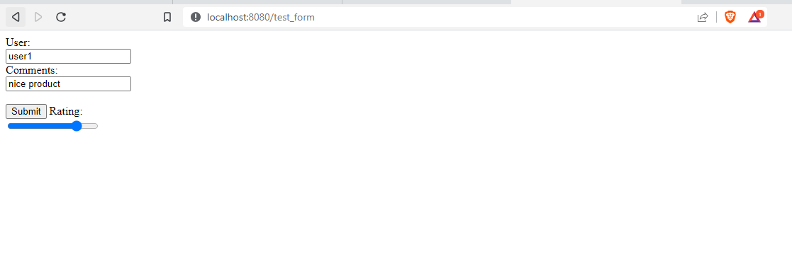

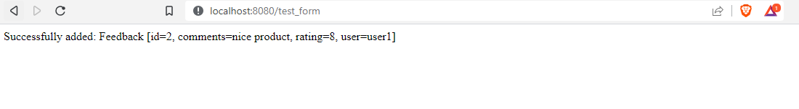

**See All Feed Back**

